Danielle Nimako

Ist 263 Site Map



**Page one photo**

* **User: dapedwa**
* **Source:** [**https://pixabay.com/photos/ghetto-downtown-street-urban-city-2012259/**](https://pixabay.com/photos/ghetto-downtown-street-urban-city-2012259/)
* **Licensed for re use**

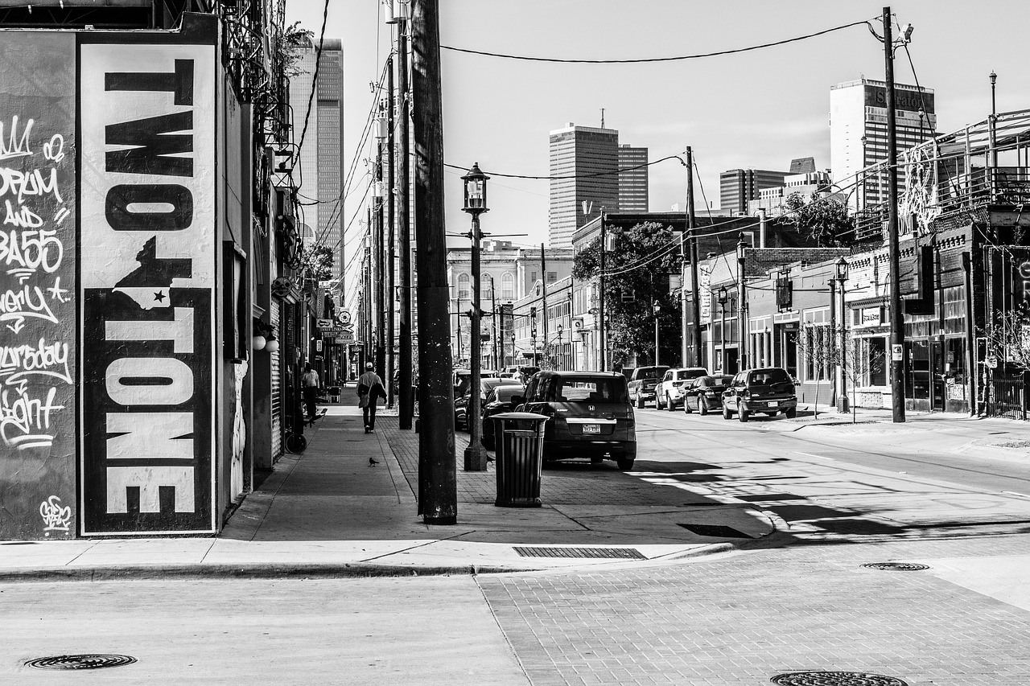

**Page 2 photo & source: -**[**http://dailyorange.com/2018/09/syracuse-poverty-rate-edges-despite-national-decrease/**](http://dailyorange.com/2018/09/syracuse-poverty-rate-edges-despite-national-decrease/)

* **Licensed for reuse**
* **User: the Daily Orange**

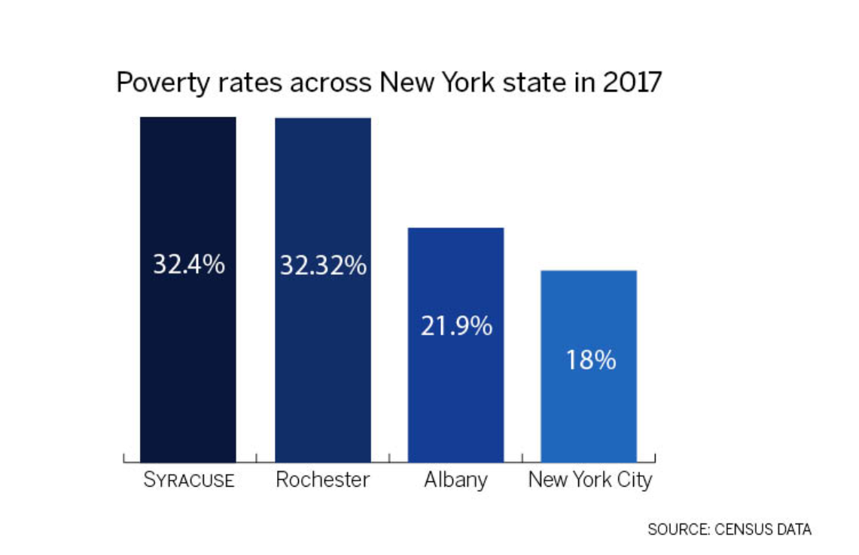

**Page 2 photo & Source:**

* **Licensed for reuse**
* **User: photos from Syracuse City School District**

[**https://www.flickr.com/photos/scsd/37572606016/in/photolist-ZfaqL1-sbFemk-f2AALk-rrdbRF-ojbisK-221Bgcm-aBecUx-aAFF1K-HhdsWb-HhdsYf-cCmo7U-J4spbW-J4speb-HMJu9o-aAJy4J-J6HBdt-HhdsZN-J4spdE-GCQQao-SpaGZR-aBea8P-aBedwB-aAJMbh-aBj47A-aAGbmf-aBgrx8-aADbm6-aBgnrr-221BeiG-221Bj3G-aBj61y-aBecmR-aBirBn-aBma7u-aBgqM4-aBebxT-aBebhM-aBmcdq-aBgRvU-aBecCi-aBj6D5-aBmcCq-aBebKT-aBec4K-2fLFWjq-aBm6UW-Yixpdf-aBgnZz-aBgUqE-aBmgzb**](https://www.flickr.com/photos/scsd/37572606016/in/photolist-ZfaqL1-sbFemk-f2AALk-rrdbRF-ojbisK-221Bgcm-aBecUx-aAFF1K-HhdsWb-HhdsYf-cCmo7U-J4spbW-J4speb-HMJu9o-aAJy4J-J6HBdt-HhdsZN-J4spdE-GCQQao-SpaGZR-aBea8P-aBedwB-aAJMbh-aBj47A-aAGbmf-aBgrx8-aADbm6-aBgnrr-221BeiG-221Bj3G-aBj61y-aBecmR-aBirBn-aBma7u-aBgqM4-aBebxT-aBebhM-aBmcdq-aBgRvU-aBecCi-aBj6D5-aBmcCq-aBebKT-aBec4K-2fLFWjq-aBm6UW-Yixpdf-aBgnZz-aBgUqE-aBmgzb)

<https://www.flickr.com/photos/fmsc/17186095207/in/photolist-ZfaqL1-sbFemk-f2AALk-rrdbRF-ojbisK-221Bgcm-aBecUx-aAFF1K-HhdsWb-HhdsYf-cCmo7U-J4spbW-J4speb-HMJu9o-aAJy4J-J6HBdt-HhdsZN-J4spdE-GCQQao-SpaGZR-aBea8P-aBedwB-aAJMbh-aBj47A-aAGbmf-aBgrx8-aADbm6-aBgnrr-221BeiG-221Bj3G-aBj61y-aBecmR-aBirBn-aBma7u-aBgqM4-aBebxT-aBebhM-aBmcdq-aBgRvU-aBecCi-aBj6D5-aBmcCq-aBebKT-aBec4K-2fLFWjq-aBm6UW-Yixpdf-aBgnZz-aBgUqE-aBmgzb/>



